**Assignment 7 Due Date: 05/23/2021(End of Day)**

Please follow the instructions uploaded to Blackboard to connect your Fedora Server Virtual Machine to the Internet then answer the questions below:

1- Did you receive any error while connecting your VM to the internet? Insert a screenshot of the error.

Answer: no

Error:

2- If you were able to follow the instructions, were you able to ping outside websites like [www.google.com](http://www.google.com)?

Answer: yes

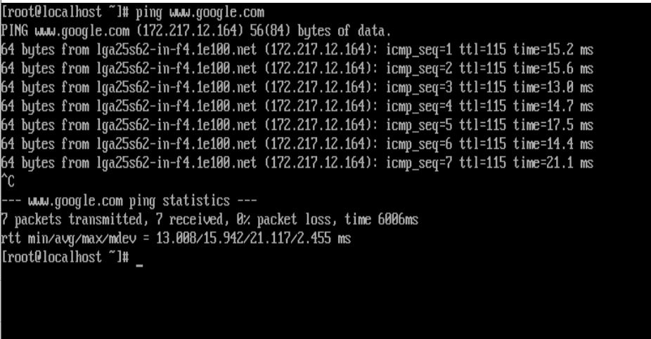

3- Were you able to find your VM ip address with ifconfig command? What is your ip address?

Answer

My ip Address is: 192.168.56.101